
WOMEN’S LIVELIHOOD FEDERATION
169,Vaiyapuri Chettiyar Lane ,Bye-Pass Road, Kodumudi
Erode-638151
PH.NO:9442049435/Email-erodewlf2022@gmail.com

SUB COMMITTEE TRAINING AND MEMBER TRAINING

PLACE: Don Bosco Media Center,Manikandam,Trichy Date: 09.10.2024

SUB COMMITTEE TRAINING :

"Mr. Ayyappan from the Dhwani Foundation gave an orientation about the roles and responsibilities of the subcommittee members to the WLF members."

THE SUBCOMMITTEES ARE AS FOLLOWS:

- Advocacy and Policy Influence
- Member Capacity Building
- Resource Mobilization
- Networking and Collaboration
- Communication and Awareness building
- Standards and Accountability
- Sustainability and Impact

Advocacy and Policy Influence
- Research relevant policies and advocate for changes that support the organization's mission.
- Engage with policymakers, stakeholders, and community leaders to influence decisions.
- Develop policy briefs and position papers to articulate the organization's stance on key issues.
- Organize campaigns and events to raise awareness about important advocacy topics.
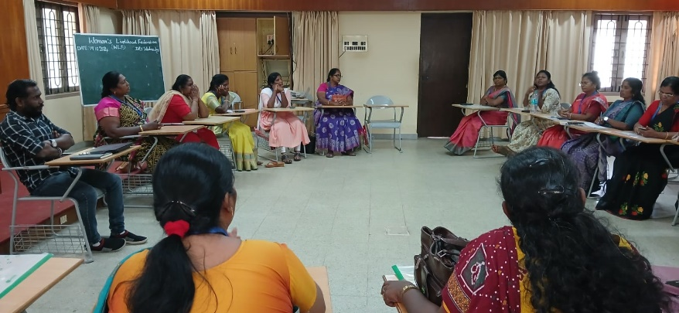

Member Capacity Building
- Assess the training needs of members to identify areas for development.
- Design and implement training programs and workshops to enhance skills and knowledge.
- Facilitate mentoring and peer support opportunities among members.
- Evaluate the effectiveness of capacity-building initiatives and make improvements.

Resource Mobilization
- Identify potential funding sources, including grants, sponsorships, and donations.
- Develop proposals and applications to secure financial and in-kind support.
- Build and maintain relationships with donors and funding organizations.
- Monitor and report on the use of resources to ensure transparency and accountability.

Networking and Collaboration
- Foster partnerships with other organizations, stakeholders, and community groups.
- Organize networking events and forums to facilitate collaboration.
- Share best practices and resources among members to enhance collective impact.
- Maintain an updated directory of contacts and partnerships for effective communication.

Communication and Awareness Building
- Develop a communication strategy to promote the organization’s goals and activities.
- Create content for newsletters, social media, and other communication channels.
- Organize campaigns to raise awareness about key issues and the organization's work.
- Engage with the media to amplify the organization's message and reach a broader audience.

Standards and Accountability
- Establish and promote standards for ethical conduct and accountability within the organization.
- Monitor compliance with established standards and guidelines.
- Conduct regular evaluations and assessments of programs and activities.
- Provide recommendations for improvement based on evaluations and feedback.

Sustainability and Impact
- Develop strategies to ensure the long-term sustainability of programs and initiatives.
- Assess the impact of projects and programs through data collection and analysis.
- Engage stakeholders in discussions about sustainability and impact assessment.
- Report on the outcomes and effectiveness of initiatives to stakeholders and the community.

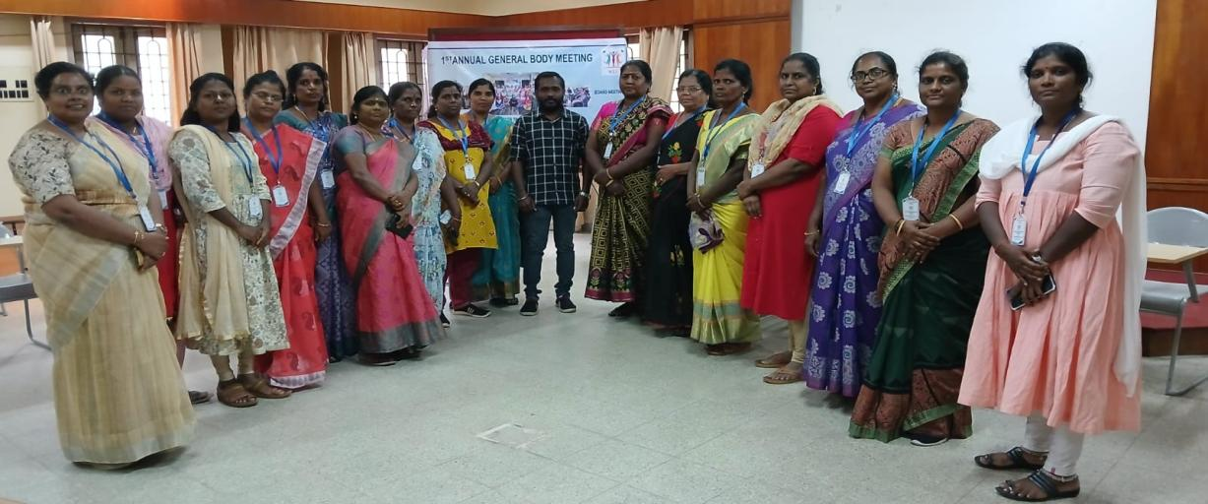

AFTERNOON SESSION :

Mrs. Esther Rani provided an orientation on the accountability and challenges faced by women leaders.

RESPONSIBILITY

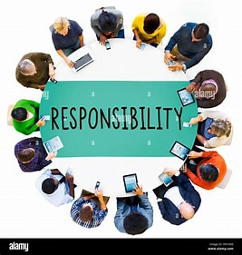
Women leaders in NGOs play a crucial role in driving social change and community development, taking on a diverse range of responsibilities vital for their organizations’ success. They provide strategic leadership by defining the organization's vision and aligning activities with community needs. Their role includes designing and implementing programs that address key issues such as education, health, and gender equality while fostering community engagement. Financial stewardship is essential, as they oversee budgeting and fundraising efforts, building relationships with donors and stakeholders. Additionally, they focus on capacity building by mentoring their teams and promoting professional growth. Lastly, women leaders ensure program effectiveness through monitoring and evaluation, maintaining transparency with stakeholders. Overall, their multifaceted responsibilities not only advance their organizations’ missions but also inspire future generations of women in the sector.

ACCOUNTABILITY:
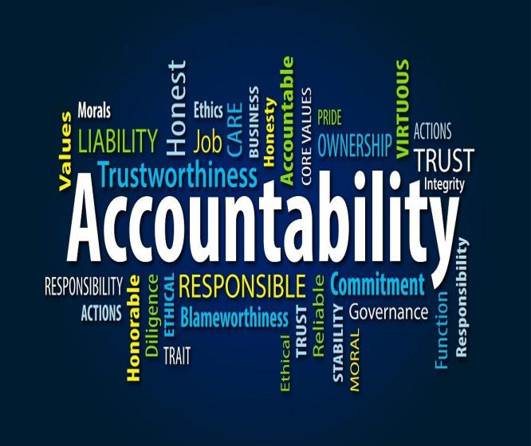
Accountability is fundamental to effective leadership in NGOs, particularly for women leaders who face unique challenges. These leaders prioritize transparency by keeping all stakeholders—donors, beneficiaries, and community members—informed about decisions, program activities, and financial expenditures. They uphold ethical standards and ensure compliance with regulations, promoting integrity in all practices. Additionally, they actively seek feedback from beneficiaries to adapt programs to community needs, enhancing their relevance and effectiveness. By rigorously evaluating program impacts and being open to scrutiny, women leaders not only build credibility for their organizations but also advocate for systemic changes that drive social progress.

CHALLENGES:

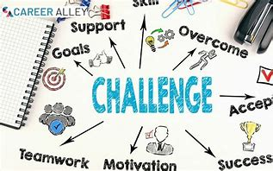
Women leaders in NGOs encounter several challenges that can hinder their effectiveness and the success of their organizations. Gender bias often undermines their authority, as stereotypes about women's leadership abilities can lead to a lack of support from stakeholders. Additionally, many women-led NGOs struggle with securing funding and resources, making program development difficult. Balancing professional responsibilities with family obligations adds to the stress, often resulting in burnout. Institutional barriers and a lack of supportive networks further limit their opportunities for advancement. Networking in male-dominated spaces can also be challenging, requiring women to overcome biases to build credibility. Despite these obstacles, women leaders continue to make significant contributions, using their experiences to advocate for change and inspire future generations.

IMPACT OF WOMEN LEADERSHIP IN NGOS

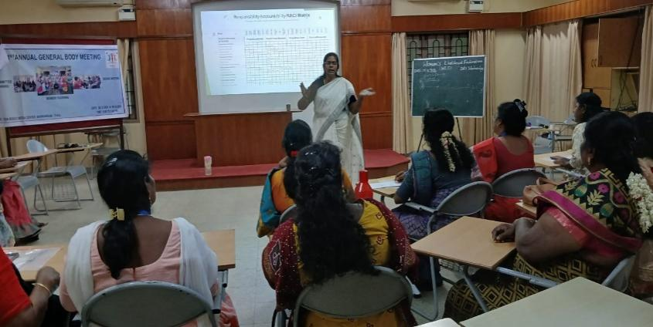
- Enhanced Collaboration:
Women leaders often foster a collaborative environment that values diverse perspectives. Their leadership style typically encourages teamwork and inclusivity, leading to stronger partnerships both within the organization and with external stakeholders. This collaborative approach enhances problem-solving capabilities and innovation, ultimately benefiting the organization's mission.

- Effective Mentorship:
Women leaders serve as vital mentors for emerging female professionals in the NGO sector. By sharing their experiences and insights, they empower the next generation of leaders, helping them navigate challenges and build confidence. This mentorship not only cultivates talent but also strengthens the organizational culture by promoting growth and development.

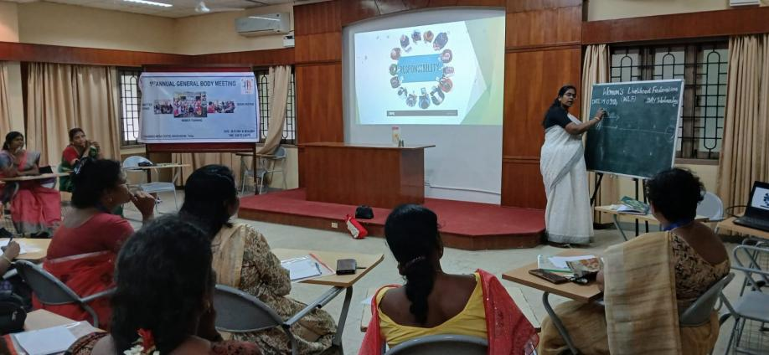
3.Community Engagement:
Women leaders tend to prioritize community involvement and responsiveness, ensuring that the voices of beneficiaries are heard and considered in decision-making processes. Their emphasis on grassroots engagement builds trust and fosters a sense of ownership among community members, resulting in more relevant and effective programs.

- Proactive Adaptability:
Women leaders are often adept at navigating change and uncertainty. Their ability to adapt proactively to evolving circumstances enables organizations to respond effectively to challenges and seize new opportunities. This adaptability is crucial in the dynamic landscape of the NGO sector, where responsiveness can significantly impact program success.

- Empathetic Decision-Making:
Empathy is a hallmark of women’s leadership, allowing them to consider the emotional and social implications of their decisions. This empathetic approach leads to more compassionate and inclusive policies that prioritize the well-being of both staff and community members. By valuing human connections, women leaders create a supportive organizational culture that enhances overall morale and effectiveness.

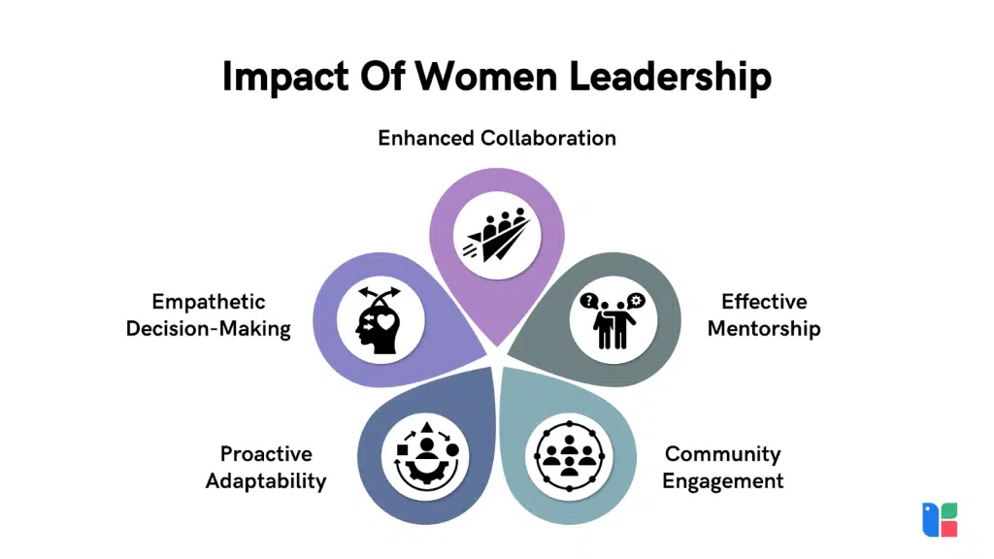

The RACI matrix is a powerful tool used to clarify roles and responsibilities within a project or organization, especially in the context of responsibility and accountability. RACI stands for Responsible, Accountable, Consulted, and Informed, and it helps teams define who is involved in various tasks and decision-making processes.

Components of the RACI Matrix:

- Responsible (R):
  - This designates individuals or teams who are responsible for executing a task or activity. They are the doers who carry out the work. Each task should have at least one person assigned as responsible to ensure clear ownership.
- Accountable (A):
  - This refers to the person ultimately accountable for the task's completion and quality. This role ensures that the task is done correctly and is often the one who signs off on the work. Ideally, each task should have only one accountable person to avoid confusion.
- Consulted (C):
  - These are individuals or groups whose opinions are sought during the task. They provide input, feedback, and expertise, and their involvement is critical for informed decision-making. This communication is typically two-way, allowing for collaboration.
- Informed (I):
  - This category includes those who need to be kept updated on the progress and outcomes of the task but are not directly involved in the work. Communication to these individuals is one-way, ensuring they are aware of developments without requiring their input.
Benefits of Using a RACI Matrix:
- Clarity: It clearly defines roles and responsibilities, reducing ambiguity and ensuring everyone understands their contributions.
- Improved Communication: By identifying who needs to be consulted or informed, the matrix enhances communication among team members and stakeholders.
- Efficient Project Management: It helps streamline processes and prevent overlapping responsibilities, leading to more efficient project execution.
- Accountability: By designating specific individuals as accountable, the matrix fosters a culture of accountability, where everyone knows who is responsible for what.
Implementation:
To create a RACI matrix, follow these steps:
- Identify Tasks: List all tasks or activities involved in the project.
- Define Roles: Determine who will be involved in each task.
- Assign RACI Codes: For each task, assign R, A, C, or I to the relevant individuals or teams.
- Review and Adjust: Share the matrix with the team for feedback and make necessary adjustments to ensure clarity and agreement.

CONCLUSION :

At the end of the day, board members and member organizations discussed the federation's upcoming activities, outlining the roles and responsibilities of the board members. They also reviewed member subscriptions and the Niranthara Lite process, including the fees structure. Additionally, the WLF will provide certificates to member NGOs, along with a registration number for each organization in the federation. This collaborative discussion has set a clear path forward for enhancing engagement and support within the federation.

